Secure Campus Network Using Cisco Packet Tracer

Mini Project Report and Implementation Evidence

Prepared from the supplied project brief and six implementation screenshots.

Project Objective
To design a small campus network in Cisco Packet Tracer and apply basic network-device security. The project covers router and switch configuration, IP addressing, console and privileged-mode passwords, SSH remote access, password obfuscation, switch port security, and verification commands.

Network Design and Devices
The topology uses one Cisco 2911 router (R1), two Cisco 2960 switches (S1 and S2), and six PCs. R1 connects two IPv4 networks: 192.168.10.0/24 and 192.168.20.0/24. S1 serves PC1–PC3, while S2 serves PC4–PC6. Copper straight-through cables are used for the links.

Implementation Steps
Step 1 — Build the topology: Place R1, S1, S2 and six PCs in the Packet Tracer workspace. Connect R1 G0/0 to S1 G0/1 and R1 G0/1 to S2 G0/1. Connect each switch’s Fa0/1–Fa0/3 ports to its three PCs.

Step 2 — Configure the router: Set hostname R1, assign 192.168.10.1/24 to G0/0 and 192.168.20.1/24 to G0/1, and enable both interfaces with no shutdown. Use show ip interface brief to inspect interface status.

Step 3 — Secure router access: Configure a console password under line console 0 and use enable secret for privileged EXEC access. Enable service password-encryption to obfuscate applicable line passwords in the configuration.

Step 4 — Enable SSH on R1: Configure the domain name campus.local, create a local admin account with a secret, generate RSA keys, select SSH version 2, and set the VTY lines to login local and transport input ssh.

Step 5 — Configure S1 and S2: Set hostnames, enable secrets, password encryption, management IP addresses on VLAN 1, and the corresponding default gateways. Configure console access and SSH on both switches using local credentials and RSA keys.

Step 6 — Enable port security: On PC-facing switch ports Fa0/1–Fa0/3, set access mode, enable port security, allow one secure MAC address, enable sticky MAC learning, and set violation mode to shutdown. Apply the equivalent settings on S2.

Step 7 — Configure PC addresses: PC1 192.168.10.10, PC2 .11, PC3 .12 with gateway 192.168.10.1; PC4 192.168.20.10, PC5 .11, PC6 .12 with gateway 192.168.20.1. Use subnet mask 255.255.255.0 for all PCs.

Step 8 — Verify and save: Test pings between PCs and router interfaces; test SSH access to the router and switches; inspect port security with show port-security and show port-security address; shut down unused ports Fa0/4–Fa0/24; save configurations using copy running-config startup-config.

IP Addressing Plan
R1 G0/0 — 192.168.10.1/24; R1 G0/1 — 192.168.20.1/24. S1 VLAN 1 — 192.168.10.2/24, gateway 192.168.10.1. S2 VLAN 1 — 192.168.20.2/24, gateway 192.168.20.1. PC1–PC3 use 192.168.10.10–12/24 and gateway 192.168.10.1. PC4–PC6 use
192.168.20.10–12/24 and gateway 192.168.20.1.

Evidence and Observations
The supplied screenshots show the Packet Tracer topology, router interface configuration/status output, and switch CLI output associated with port-security configuration and a port-security violation/recovery sequence. The topology screenshot shows the router connected to two switches and six PCs. The router CLI screenshots show interface status/configuration output. The switch CLI screenshot includes a port-security violation message. These screenshots document implementation activity; they do not by themselves prove every listed ping and SSH test succeeded.

Security Features Used

Console password: protects local console login. Enable secret: protects privileged EXEC mode. service password-encryption: obfuscates applicable plaintext line passwords in the configuration, but is not strong cryptographic protection. SSH version 2: provides encrypted remote administration. Port security with sticky MAC learning: restricts each PC-facing port to one learned/allowed MAC address. Violation mode shutdown: places the port into an error-disabled/shutdown state when the security violation occurs. Shutting unused ports reduces opportunities for unauthorized connections.

Testing Checklist
Record the actual result after running each test in Packet Tracer:
  - PC1 → 192.168.10.1 ping
  - PC1 → PC4 (192.168.20.10) ping
  - SSH from PC1 to S1 (192.168.10.2)
  - SSH from PC1 to R1 (192.168.10.1)
  - SSH from PC4 to S2 (192.168.20.2)
  - show port-security / show port-security address
  - Demonstrate an unauthorized MAC-address violation
  - Confirm unused switch ports are shutdown

Only mark a test as successful after observing the corresponding output.

Conclusion
This mini project provides practical experience in configuring a small two-subnet campus network and applying basic Cisco device security. It combines IP connectivity, device access protection, SSH-based administration, password obfuscation, port-security controls, and verification commands. The screenshots provide evidence of the topology and selected configuration/testing steps.

10. Screenshots and Steps Evidenced

Screenshot 1 — Switch port status
The switch CLI displays interface status and port information. Use this image as evidence of inspecting switch interfaces.
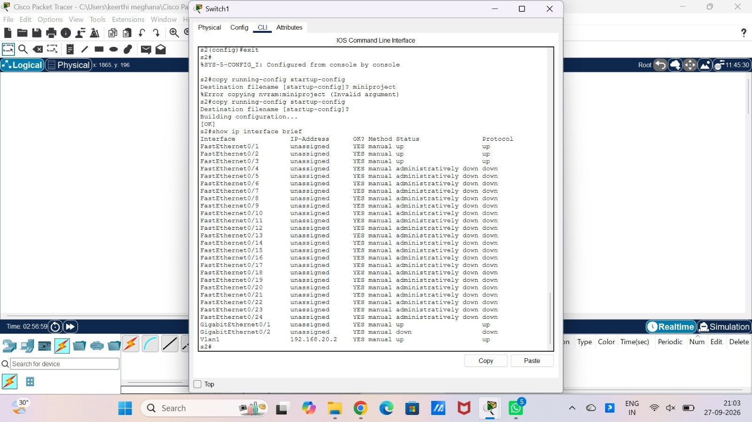

Screenshot 2 — Port-security violation
The CLI output includes a port-security violation message and follow-up interface commands. This supports the port-security demonstration.
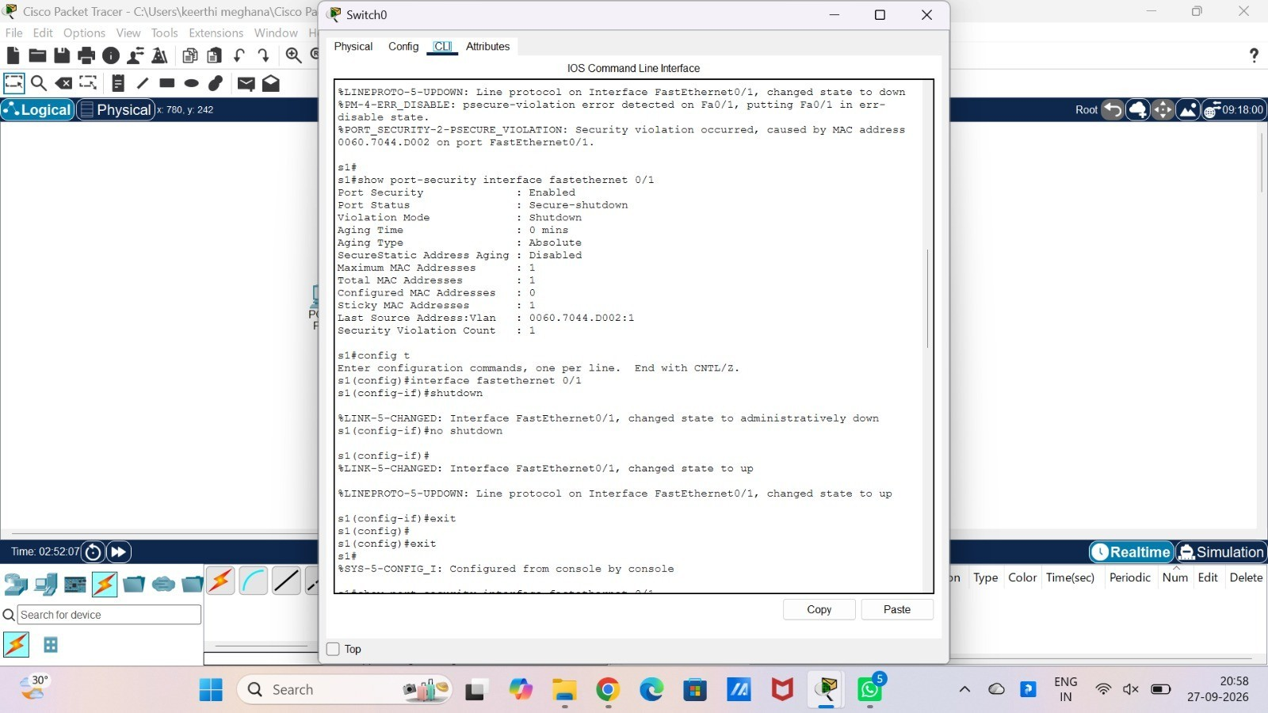

Screenshot 3 — Network topology
The Packet Tracer workspace shows one router, two switches and six PCs connected in the intended two-LAN layout.

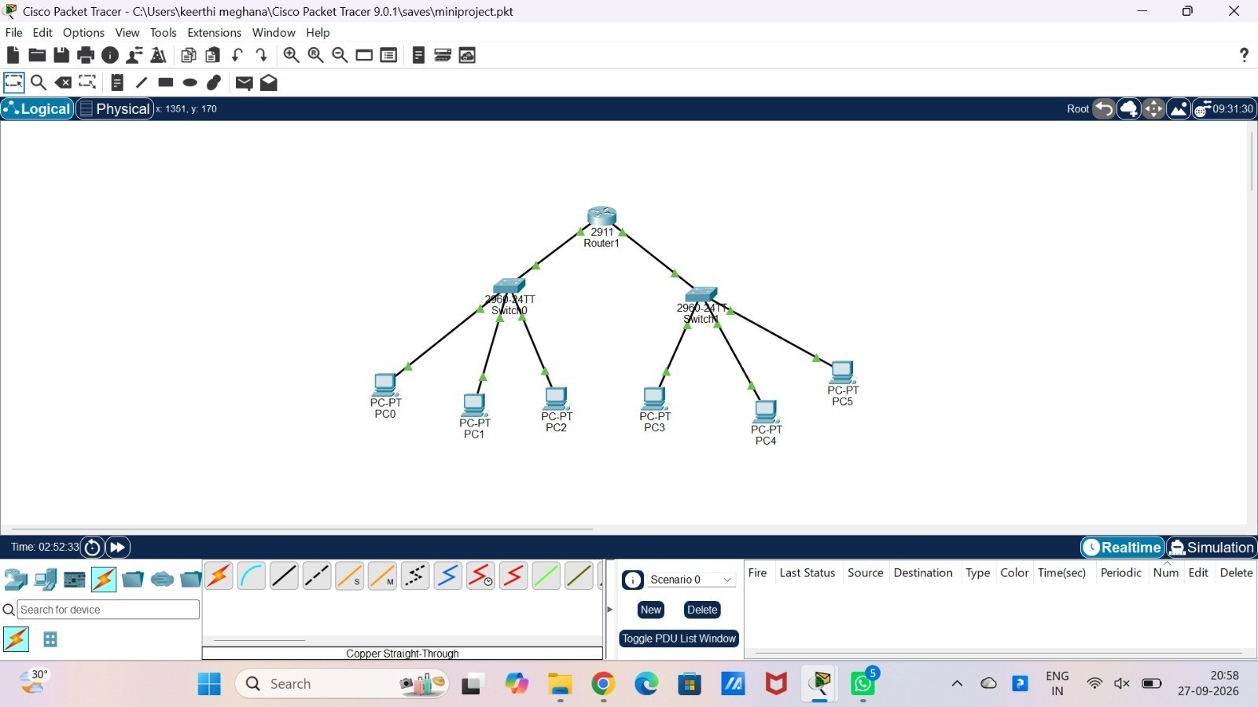

Screenshot 4 — Router interfaces
The router CLI shows interface configuration and the show ip interface brief command/output.
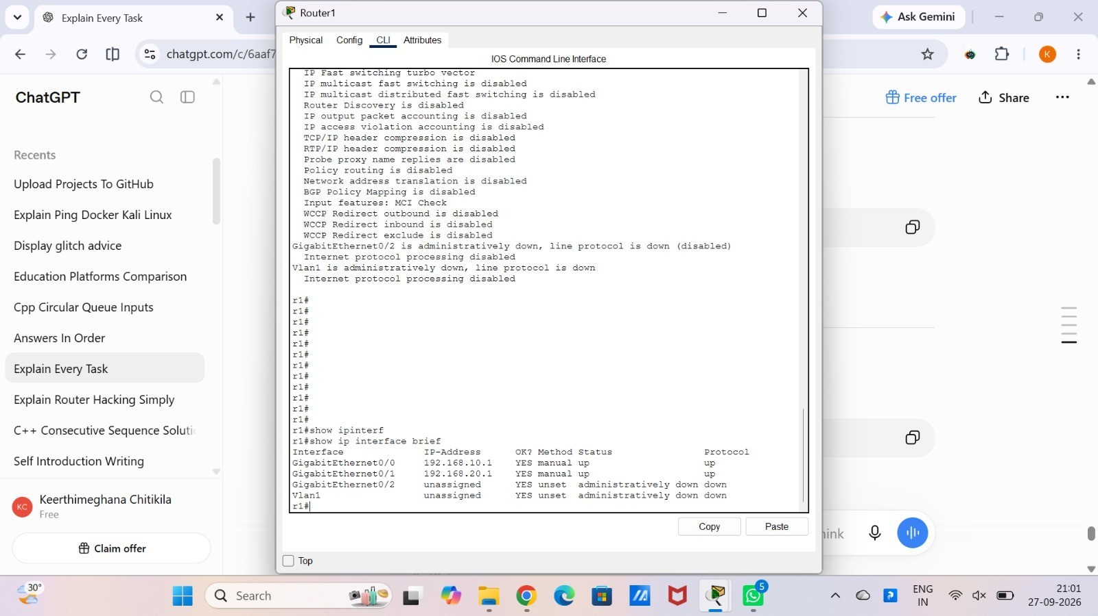

Screenshot 5 — Router status
The router CLI displays interface/status information used during configuration verification.

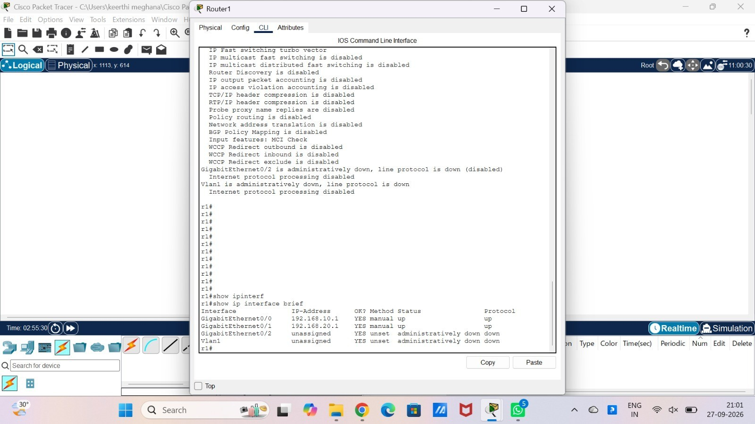

Screenshot 6 — Switch status
The switch CLI displays interface/status output for inspection.
